**Supply Chain Database**

This project implements a relational database for managing supply chain operations using MySQL. The database is designed to handle essential components of the supply chain, including customers, orders, order items, products and suppliers.

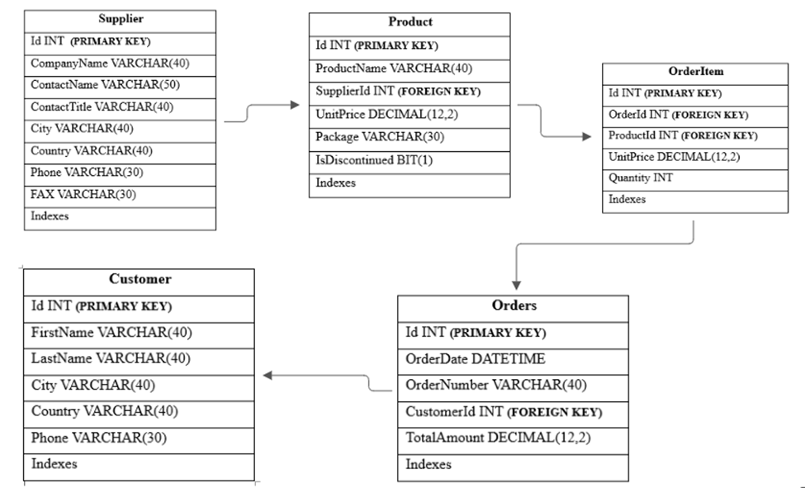

**Business Problem:**

Richard’s Supply is a distribution company that partners with network suppliers to provide a wide range of products to customers across different countries. Over the past two years, the company has assumed a significant amount of operational data, including details on suppliers, products, customers, orders and transactions.

However, despite maintaining the extensive database, Richard’s supply has limited visibility of key aspects of its operations. The company faces challenges in answering critical business questions such as:

* Which supplier contributes most significantly to the supply chain?
* Which products are in highest demand?
* Which customers are inactive or under-engaged?
* What is the financial impact of discounts on product sales?
* How can they support potential new suppliers to make informed decisions?

Richard’s supply aims to harness this data to improve operational efficiency, strengthen supplier relationships and drive customer satisfaction. A Systemic approach is required to transform the raw data into actionable insights that inform decision-making across the business.

**Objectives:**

**Data integration and validation:**

* Extract and validate data from multiple interconnected tables (supplier, products, customer, order, orderitems).
* Ensure data accuracy and consistency of relatable analysis.

**Comprehensive Business Reporting:**

* Answer the business questions using SQL, focusing on customer segmentation, supplier performance, product availability, order trends and revenue analysis.

**Customer Analytics:**

* Identify active and inactive customers
* Analyze customer ordering patterns to inform targeted marketing efforts and improve retention.

**Supplier performance Analysis:**

* Identify suppliers with the targeted product portfolio and highest revenue contributions.
* Understand suppliers’ distribution across countries to highlight potential gaps or opportunities for diversifications.

**Goals**

**Unlock Customer Insights:**

* Profile customers by country and city to understand regional preferences
* Identify customers with high order value and highlight opportunities for loyalty program

**Optimize Supplier Relationships:**

* Recognize the relationship of suppliers with most products and those generating the highest revenues.
* Determine which countries have the most active suppliers and where there may be gaps.

**Refine Product Strategy:**

* Rank Products based on demand of customers and order volumes.
* Highlight products with unit prices to inform premium products marketing planning.

**Support Data Driven Decisions:**

* Provide a management team with clear, insightful reports that support strategic planning.
* Establish a foundation for future predictive analytics and demand forecasting

**Enhance Supply Chain Resilience:**

* Identify reliance on foreign suppliers for key products
* Highlight countries that supply products to the UK to inform risk mitigation strategies

**Outcomes:**

By addressing questions across four levels of complexity from basic data retrieval to advanced analytics this project transforms a raw supply chain dataset into a powerful decision-making tool. The insights generated from this analysis will enable Richard’s Supply to:

* Build stronger relationships with top-performing suppliers.
* Optimize product offerings to meet customer demand.
* Identify at-risk customers and engage them with targeted marketing efforts.
* Provide recommendations for new suppliers to enter the market effectively.
* Improve revenue forecasting and financial planning.